**Project Design Phase-II**

**Data Flow Diagram & User Stories**

|  |  |
| --- | --- |
| Date | 18 October 2022 |
| Team ID | PNT2022TMID24222 |
| Project Name | GAS LEAKAGE MONITORING AND ALERTING SYSTEM FOR INDUSTRIES |
| Maximum Marks | 4 Marks |

**Data Flow Diagrams:**

A Data Flow Diagram (DFD) is a traditional visual representation of the information flows within a system. A neat and clear DFD can depict the right amount of the system requirement graphically. It shows how data enters and leaves the system, what changes the information, and where data is stored.

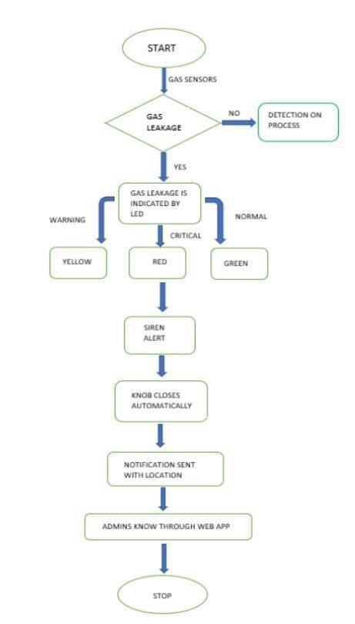

**User Stories**

|  |  |  |  |  |  |  |
| --- | --- | --- | --- | --- | --- | --- |
| **User Type** | **Functional**  **Requirement**  **(Epic)** | **User Story**  **Number** | **User Story / Task** | **Acceptance criteria** | **Priority** | **Release** |
| Customer  (Mobile user) | Registration | USN-1 | As a user, I can register for the application by entering my email, password, and confirming my password. | I can access my account / dashboard | High | Sprint-1 |
|  |  | USN-2 | As a user, I will receive confirmation email once I have registered for the application | I can receive confirmation email & click confirm | High | Sprint-1 |
|  |  | USN-3 | As a user, I can register for the application through Facebook | I can register & access the dashboard with Facebook Login | Low | Sprint-2 |
|  |  | USN-4 | As a user, I can register for the application through Gmail |  | Medium | Sprint-1 |
|  | Login | USN-5 | As a user, I can log into the application by entering email & password |  | High | Sprint-1 |
| Customer (Web  user) | Registration | USN-1 | As a user, I can register for the application by google. | I can access confirmation email. | High | Sprint-1 |
|  |  | USN-2 | As a user, I can register for the application by firebox | I can access confirmation Login | low | Sprint-2 |
|  | Login | USN-3 | As a user, I can register for the application through Gmail. |  | Medium | Sprint-1 |
| Administrator | Registration | USN-1 | As a user, I can register for the application through Mobile app. | I can access confirmation My account. | High | Sprint-1 |
|  |  | USN-2 | As a user, I can register for the application through Mobile app. | I can access confirmation email | low | Sprint-2 |